

Artificial Intelligence and Expert System Lab (CSE 404)

Department of CSE

Assignment No: 01

|  |  |
| --- | --- |
| Topic/Question: | Implementing a basic family tree structure of my own family using Prolog. Write rules against 1st cousin, 2nd cousin, 1st cousin once removed and 1st cousin twice removed. |

|  |  |
| --- | --- |
| Tools: |  |
| 1. | SWI-Prolog |
| 2. | Drawio.net (for drawing) |
| 3. | Notepad++ (text editor) |

Date of Submission: 21 Jan, 2021

|  |  |
| --- | --- |
| Submitted by | Submitted to |
| Name: Niamul Hasan  Id: **17201026**  Semester: 4.1  Section: A1 | Dr. Nasima Begum  Assistant Professor  Department of CSE  UAP |

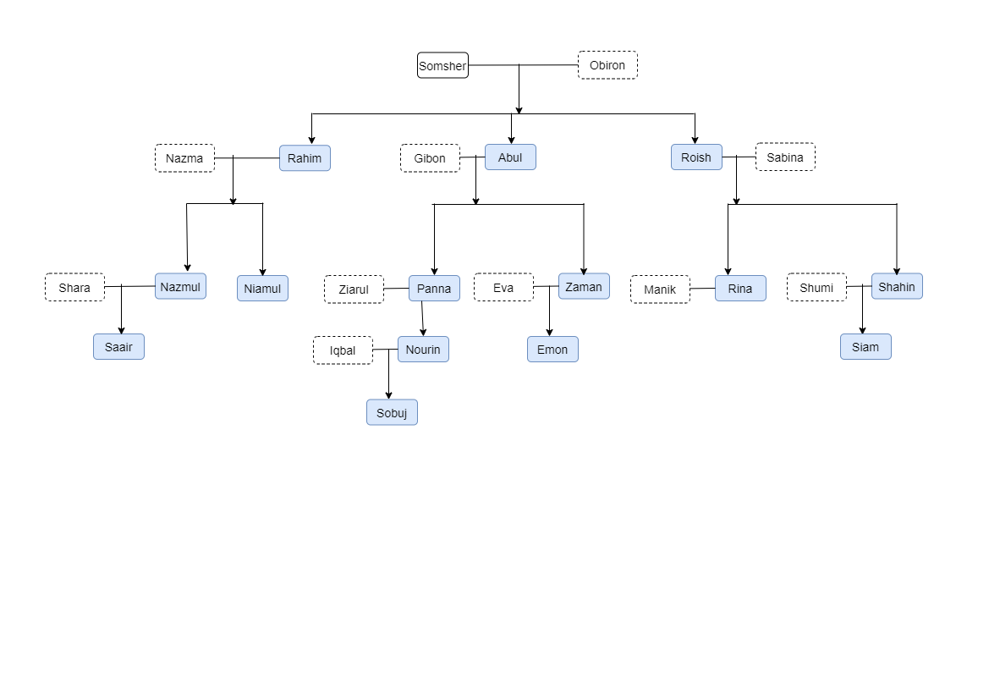

**Rules against 1st cousin:(result)**

|  |  |
| --- | --- |
| firstcousin(X,Y).  nazmul --> first Cousin --> panna  X = nazmul,  Y = panna ;  nazmul --> first Cousin --> zaman  X = nazmul,  Y = zaman ;  nazmul --> first Cousin --> rina  X = nazmul,  Y = rina ;  nazmul --> first Cousin --> shahin  X = nazmul,  Y = shahin ;  niamul --> first Cousin --> panna  X = niamul,  Y = panna ;  niamul --> first Cousin --> zaman  X = niamul,  Y = zaman ;  niamul --> first Cousin --> rina  X = niamul,  Y = rina ;  niamul --> first Cousin --> shahin  X = niamul,  Y = shahin ;  panna --> first Cousin --> nazmul  X = panna,  Y = nazmul ;  panna --> first Cousin --> niamul  X = panna,  Y = niamul ;  panna --> first Cousin --> rina  X = panna,  Y = rina ;  panna --> first Cousin --> shahin  X = panna,  Y = shahin ;  zaman --> first Cousin --> nazmul  X = zaman,  Y = nazmul ;  zaman --> first Cousin --> niamul  X = zaman,  Y = niamul ;  zaman --> first Cousin --> rina  X = zaman,  Y = rina ;  zaman --> first Cousin --> shahin  X = zaman,  Y = shahin ;  rina --> first Cousin --> nazmul  X = rina,  Y = nazmul ;  rina --> first Cousin --> niamul  X = rina,  Y = niamul ;  rina --> first Cousin --> panna  X = rina,  Y = panna ;  rina --> first Cousin --> zaman  X = rina,  Y = zaman ;  shahin --> first Cousin --> nazmul  X = shahin,  Y = nazmul ;  shahin --> first Cousin --> niamul  X = shahin,  Y = niamul ;  shahin --> first Cousin --> panna  X = shahin,  Y = panna ;  shahin --> first Cousin --> zaman  X = shahin,  Y = zaman ;  nazmul --> first Cousin --> panna  X = nazmul,  Y = panna ;  nazmul --> first Cousin --> zaman  X = nazmul,  Y = zaman ; | nazmul --> first Cousin --> rina  X = nazmul,  Y = rina ;  nazmul --> first Cousin --> shahin  X = nazmul,  Y = shahin ;  niamul --> first Cousin --> panna  X = niamul,  Y = panna ;  niamul --> first Cousin --> zaman  X = niamul,  Y = zaman ;  niamul --> first Cousin --> rina  X = niamul,  Y = rina ;  niamul --> first Cousin --> shahin  X = niamul,  Y = shahin ;  panna --> first Cousin --> nazmul  X = panna,  Y = nazmul ;  panna --> first Cousin --> niamul  X = panna,  Y = niamul ;  panna --> first Cousin --> rina  X = panna,  Y = rina ;  panna --> first Cousin --> shahin  X = panna,  Y = shahin ;  zaman --> first Cousin --> nazmul  X = zaman,  Y = nazmul ;  zaman --> first Cousin --> niamul  X = zaman,  Y = niamul ;  zaman --> first Cousin --> rina  X = zaman,  Y = rina ;  zaman --> first Cousin --> shahin  X = zaman,  Y = shahin ;  rina --> first Cousin --> nazmul  X = rina,  Y = nazmul ;  rina --> first Cousin --> niamul  X = rina,  Y = niamul ;  rina --> first Cousin --> panna  X = rina,  Y = panna ;  rina --> first Cousin --> zaman  X = rina,  Y = zaman ;  shahin --> first Cousin --> nazmul  X = shahin,  Y = niamul;  shahin --> first Cousin --> panna  X = shahin,  Y = panna ;  shahin --> first Cousin --> zaman  X = shahin,  Y = zaman ;  nourin --> first Cousin --> emon  X = nourin,  Y = emon ;  emon --> first Cousin --> nourin  X = emon,  Y = nourin ;  nourin --> first Cousin --> emon  X = nourin,  Y = emon ;  emon --> first Cousin --> nourin  X = emon,  Y = nourin ;  false. |

**Rules against 2nd cousin:(result)**

|  |  |
| --- | --- |
| ?- secondcousin(X,Y).  saair --> Second Cousin --> nourin  X = saair,  Y = nourin ;  saair --> Second Cousin --> nourin  X = saair,  Y = nourin ;  saair --> Second Cousin --> emon  X = saair,  Y = emon ;  saair --> Second Cousin --> emon  X = saair,  Y = emon ;  saair --> Second Cousin --> simam  X = saair,  Y = simam ;  saair --> Second Cousin --> simam  X = saair,  Y = simam ;  nourin --> Second Cousin --> saair  X = nourin,  Y = saair ;  nourin --> Second Cousin --> saair  X = nourin,  Y = saair ;  nourin --> Second Cousin --> simam  X = nourin,  Y = simam ;  nourin --> Second Cousin --> simam  X = nourin,  Y = simam ;  emon --> Second Cousin --> saair  X = emon,  Y = saair ; | emon --> Second Cousin --> saair  X = emon,  Y = saair ;  emon --> Second Cousin --> simam  X = emon,  Y = simam ;  emon --> Second Cousin --> simam  X = emon,  Y = simam ;  simam --> Second Cousin --> saair  X = simam,  Y = saair ;  simam --> Second Cousin --> saair  X = simam,  Y = saair ;  simam --> Second Cousin --> nourin  X = simam,  Y = nourin ;  simam --> Second Cousin --> nourin  X = simam,  Y = nourin ;  simam --> Second Cousin --> emon  X = simam,  Y = emon ;  simam --> Second Cousin --> emon  X = simam,  Y = emon ;  false. |

**Rules against 1st cousin once removed:(result)**

|  |  |
| --- | --- |
| ?- cousin_once_removed(X,Y).  nazmul --> first cousin once removed --> nourin  X = nazmul,  Y = nourin ;  nazmul --> first cousin once removed --> emon  X = nazmul,  Y = emon ;  nazmul --> first cousin once removed --> simam  X = nazmul,  Y = simam ;  niamul --> first cousin once removed --> nourin  X = niamul,  Y = nourin ;  niamul --> first cousin once removed --> emon  X = niamul,  Y = emon ;  niamul --> first cousin once removed --> simam  X = niamul,  Y = simam ;  panna --> first cousin once removed --> saair  X = panna,  Y = saair ;  panna --> first cousin once removed --> simam  X = panna,  Y = simam ;  zaman --> first cousin once removed --> saair  X = zaman,  Y = saair ;  zaman --> first cousin once removed --> simam  X = zaman,  Y = simam ;  rina --> first cousin once removed --> saair  X = rina,  Y = saair ;  rina --> first cousin once removed --> nourin  X = rina,  Y = nourin ;  rina --> first cousin once removed --> emon  X = rina,  Y = emon ;  shahin --> first cousin once removed --> saair  X = shahin,  Y = saair ;  shahin --> first cousin once removed --> nourin  X = shahin,  Y = nourin ;  shahin --> first cousin once removed --> emon  X = shahin,  Y = emon ;  nazmul --> first cousin once removed --> nourin  X = nazmul,  Y = nourin ; | nazmul --> first cousin once removed --> emon  X = nazmul,  Y = emon ;  nazmul --> first cousin once removed --> simam  X = nazmul,  Y = simam ;  niamul --> first cousin once removed --> nourin  X = niamul,  Y = nourin ;  niamul --> first cousin once removed --> emon  X = niamul,  Y = emon ;  niamul --> first cousin once removed --> simam  X = niamul,  Y = simam ;  panna --> first cousin once removed --> saair  X = panna,  Y = saair ;  panna --> first cousin once removed --> simam  X = panna,  Y = simam ;  zaman --> first cousin once removed --> saair  X = zaman,  Y = saair ;  zaman --> first cousin once removed --> simam  X = zaman,  Y = simam ;  rina --> first cousin once removed --> saair  X = rina,  Y = saair ;  rina --> first cousin once removed --> nourin  X = rina,  Y = nourin ;  rina --> first cousin once removed --> emon  X = rina,  Y = emon ;  shahin --> first cousin once removed --> saair  X = shahin,  Y = saair ;  shahin --> first cousin once removed --> nourin  X = shahin,  Y = nourin ;  shahin --> first cousin once removed --> emon  X = shahin,  Y = emon ;  emon --> first cousin once removed --> sobuj  X = emon,  Y = sobuj ;  emon --> first cousin once removed --> sobuj  X = emon,  Y = sobuj ;  false. |

**Rules against 1st cousin twice removed:(result)**

|  |  |
| --- | --- |
| ?- cousin_twice_removed(X,Y).  nazmul --> first cousin twice removed --> sobuj  X = nazmul,  Y = sobuj ;  niamul --> first cousin twice removed --> sobuj  X = niamul,  Y = sobuj ;  rina --> first cousin twice removed --> sobuj  X = rina,  Y = sobuj ;  shahin --> first cousin twice removed --> sobuj  X = shahin,  Y = sobuj ; | nazmul --> first cousin twice removed --> sobuj  X = nazmul,  Y = sobuj ;  niamul --> first cousin twice removed --> sobuj  X = niamul,  Y = sobuj ;  rina --> first cousin twice removed --> sobuj  X = rina,  Y = sobuj ;  shahin --> first cousin twice removed --> sobuj  X = shahin,  Y = sobuj ;  false. |